TASK 1:
abstract class Vehicle{
String make;
String model;
int year;
abstract double getSalePrice();
}
class car extends Vehicle{
double basePrice;
car(String make,String model,int year,double basePrice){
this.make=make;
this.model=model;
this.year=year;
this.basePrice=basePrice;
}
@Override
double getSalePrice() {
double Saleprice;
double coefficient;
int carAge = 2023 - year;
if (carAge < 3){
coefficient = 1.2;
} else if (carAge >= 3 && carAge <= 10) {
coefficient = 0.9;
}else
coefficient=0.5;
Saleprice = basePrice*coefficient;
return Saleprice;
}
}
class truck extends Vehicle{
int weightCapacity;
double baseprice;
truck(String make,String model,int year,int basePrice,int weightCapacity){
this.make=make;
this.model=model;
this.year=year;
this.baseprice=basePrice;
this.weightCapacity = weightCapacity;
}
@Override
double getSalePrice() {
double saleprice;
double Premium;
int carAge = 2023 - year;
if (weightCapacity < 2){
Premium = 5000;
} else if (carAge >= 3 && carAge <= 10) {
Premium = 10000;
}else
Premium = 20000;
saleprice = baseprice+Premium;
return saleprice;
}
}
public class Main {
public static void main(String[] args) {
Vehicle obj1 = new car("Suzki","vitara",2012,25000);
Vehicle obj2 = new truck("suzki","mazda",2003,20000,2);
System.out.println("Sale price of Car: "+obj1.getSalePrice());
System.out.println("Sale price of Truck: "+obj2.getSalePrice());
}
}
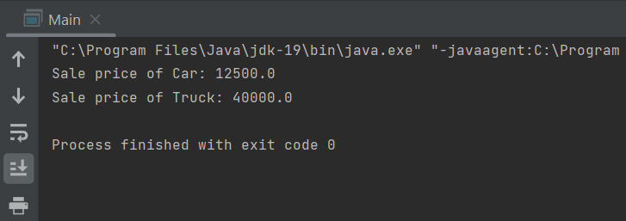
TASK 2:
abstract class Character{
int health;
int attackPower;
String name;
abstract void specialAbility();
void attack(Character char1) {
char1.health -= attackPower;
System.out.println("Now the health of " + char1.name + " is " + char1.health);
}
}
class Warrior extends Character{
Warrior(int health,int attackpower,String name){
this.health = health;
this.attackPower = attackpower;
this.name = name;
}
@Override
void specialAbility() {
this.attackPower = attackPower*2;
System.out.println("The Attack power of " + this.name + " is double");
}
}
class Mage extends Character{
Mage(int Health,int Attackpow,String Name){
this.health=Health;
this.attackPower=Attackpow;
this.name=Name;
}
@Override
void specialAbility() {
this.attackPower += 20;
System.out.println("The Attack power of " + this.name + " has increased by 20");
}
}
class Archer extends Character{
Archer(int HEALTH,int AttPow,String NAME){
this.health = HEALTH;
this.attackPower = AttPow;
this.name=NAME;
}
@Override
void specialAbility() {
this.attackPower += 15;
System.out.println("The Attack power of " + this.name + " by 15");
}
}
public class Game {
public static void main(String[] args) {
Character obj1 = new Warrior(100,50,"Strix");
Character obj2 = new Mage(120,60,"Taco");
Character obj3 = new Archer(120,30,"Goblin");
System.out.println("All Characters initial Health: \n" + obj1.name +":"+ obj1.health + "\n" + obj2.name +":"+ obj2.health + "\n" + obj3.name +":"+ obj3.health + "\n" );
System.out.println("Strix attacks Taco: \n");
obj1.attack(obj2);
System.out.println("Taco uses special Powers to attack Strix: \n");
obj2.specialAbility();
obj2.attack(obj1);
System.out.println("The outrageous Strix now attacks the Archer Goblin using his special power\n");
obj1.specialAbility();
obj1.attack(obj3);
}
}
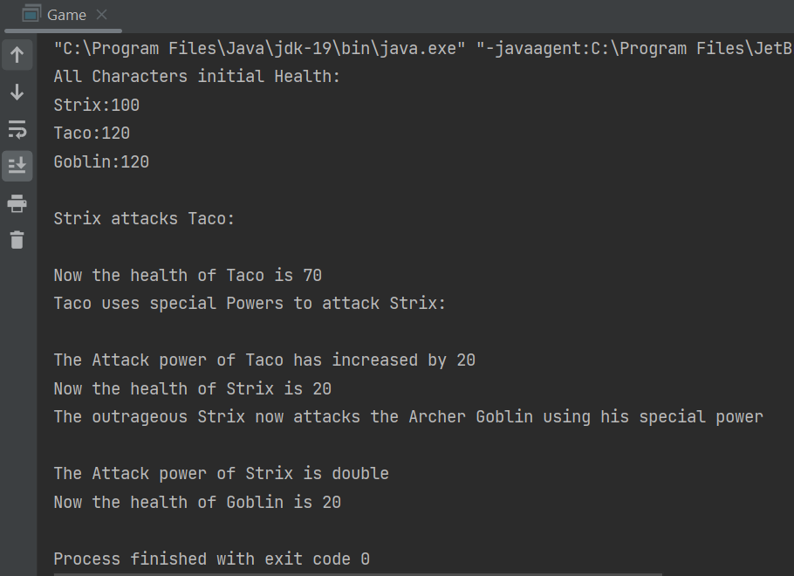
TASK 3:
import java.util.Scanner;
interface MessageService{
void send(String message,String recipient);
String receive();
}
class Whatsapp implements MessageService{
Whatsapp(){}
@Override
public void send(String message, String recipient) {
System.out.println(message + " Sent to " + recipient);
}
@Override
public String receive() {
return "You have no Message :)";
}
}
public class Q3 {
public static void main(String[] args) {
MessageService message1 = new Whatsapp();
Scanner scanner = new Scanner(System.in);
System.out.println("Enter the message to send");
String messg = scanner.nextLine();
System.out.println("Enter the recipient to send the message to");
String recp = scanner.next();
message1.send(messg,recp);
System.out.println(message1.receive());;
}
}
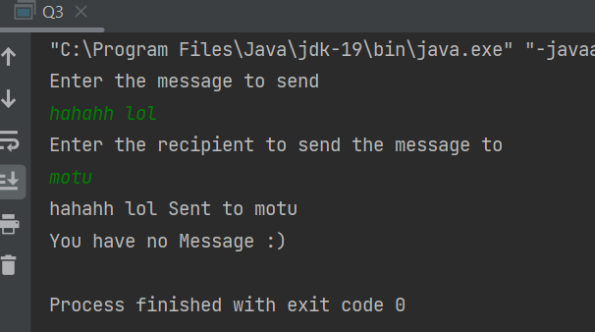
Task 4:
interface Shape {
double getArea();
double getPerimeter();
}
class Rectangle implements Shape {
private double length;
private double width;
public Rectangle(double length, double width) {
this.length = length;
this.width = width;
}
public double getArea() {
return length * width;
}
public double getPerimeter() {
return 2 * (length + width);
}
}
class Circle implements Shape {
private double radius;
private final double PI = 3.14159;
public Circle(double radius) {
this.radius = radius;
}
public double getArea() {
return PI * radius * radius;
}
public double getPerimeter() {
return 2 * PI * radius;
}
}
public class Q4 {
public static void main(String[] args) {
Shape rectangle = new Rectangle(4, 5);
Shape circle = new Circle(3);
System.out.println("Rectangle area: " + rectangle.getArea());
System.out.println("Rectangle perimeter: " + rectangle.getPerimeter());
System.out.println("Circle area: " + circle.getArea());
System.out.println("Circle perimeter: " + circle.getPerimeter());
}
}
